Centrelink Income Confirmation Consent

Authority Form

***This consent will be used for the sole purpose of authorising Centrelink to provide your income details to Dreamtime Housing and the Aboriginal Housing Office. If you do not allow Centrelink to provide your information to us electronically, you will need to obtain this information from Centrelink yourself and provide it to us.***

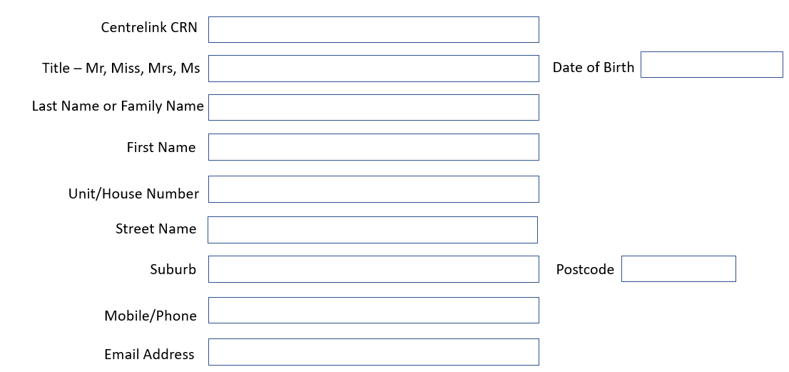

|  |  |  |
| --- | --- | --- |
| **Income Confirmation Scheme Consent** | | |
| **Please read and sign the consent below.**   * I understand the Australian Government Department of Human Services (the department) will disclose personal information to the Dreamtime Housing and the Aboriginal Housing Office (AHO) hereafter referred to as the Property Manager and Owner (PMO) including my name, payment type, payment status, one off payments, income, assets, deductions, share care arrangements and partner status to confirm my eligibility for relevant housing service. * I understand the PMO may disclose information contained in the Centrelink statement of information to a registered housing providers for the purpose of providing housing services. * I understand this consent, once signed, remains valid while I am a customer of the PMO unless I withdraw by contacting the PMO or the department. * I understand I can get proof of my circumstance/details from the department and provide it to the and the PMO so that my eligibility for relevant housing service can be determined. * I understand if I withdraw my consent or not alternatively provide proof of my circumstances/details, I may not be eligible for the housing services provided by the PMO. * I authorise PMO to use Centrelink Confirmation eServices to perform a Centrelink enquiry of my customer details in order to enable the business to determine if I qualify for a housing service. * I authorise the Australian Government Department of Human Services (the department) to provide the results of the enquiry to PMO. | | |
| **Full Name:** | **Signature** | **Date** |
| ( |  | (DD/MM/YYYY) |

More information about the Centrelink Confirmation eServices is available from a Centrelink office or on Centrelink’s

website at [www.humanservices.gov.au](http://www.humanservices.gov.au)